**CN LAB EXAM 2 REPORT**

**OBJECTIVE :-**

Set up and configure a network topology using RIP and OSPF routing protocols in Cisco Packet Tracer. Customize the network by assigning each computer a name and an IP address using the last three digits of your roll number.

**STEPS TAKEN**:

**STEP 1:**

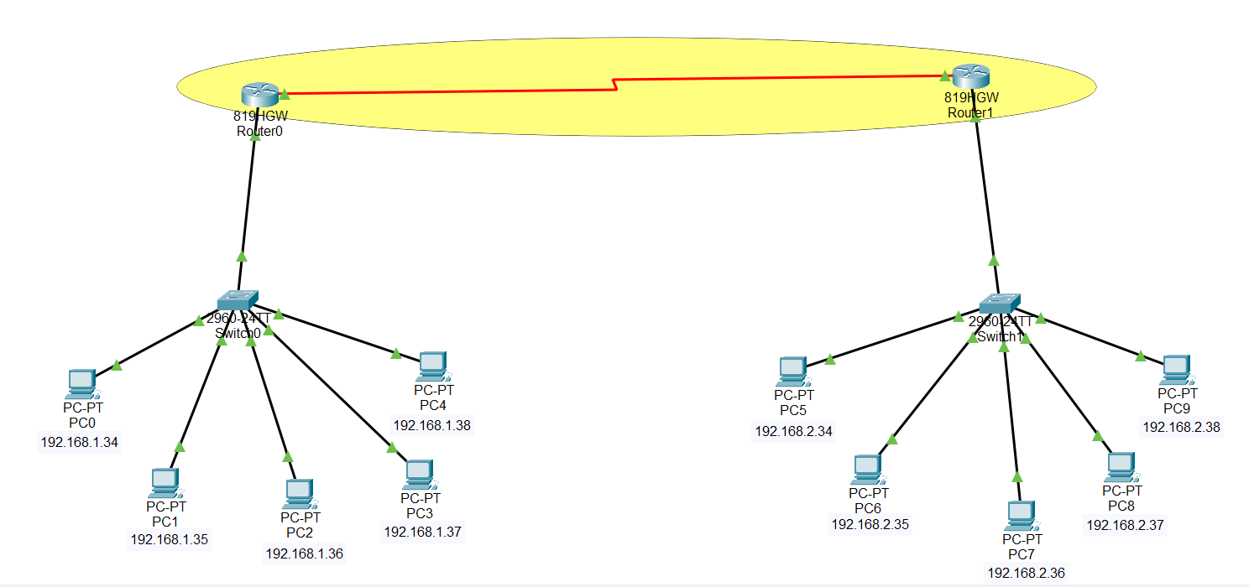

* Link the two routers with a Serial DCE-DTE cable.
* Connect the GigabitEthernet ports of R1 and R2 Routers to the Switch (SW0/SW1) ports with a straight-through cable.
* Connect PC0, PC1, PC2, PC3, PC4 to SW1, PC5, PC6, PC7, PC8, PC9 to SW2 with a straight cable.
* **STEP 2:**

After typing the below commands on the Router, the connection is successful indicated by the green triangles on the cables below.

Click on the R1 Router you made in the setup, and open the settings. After that, go to the CLI tab. Use the commands below to give IP addresses to R1’s GigabitEthernet and Serial ports.

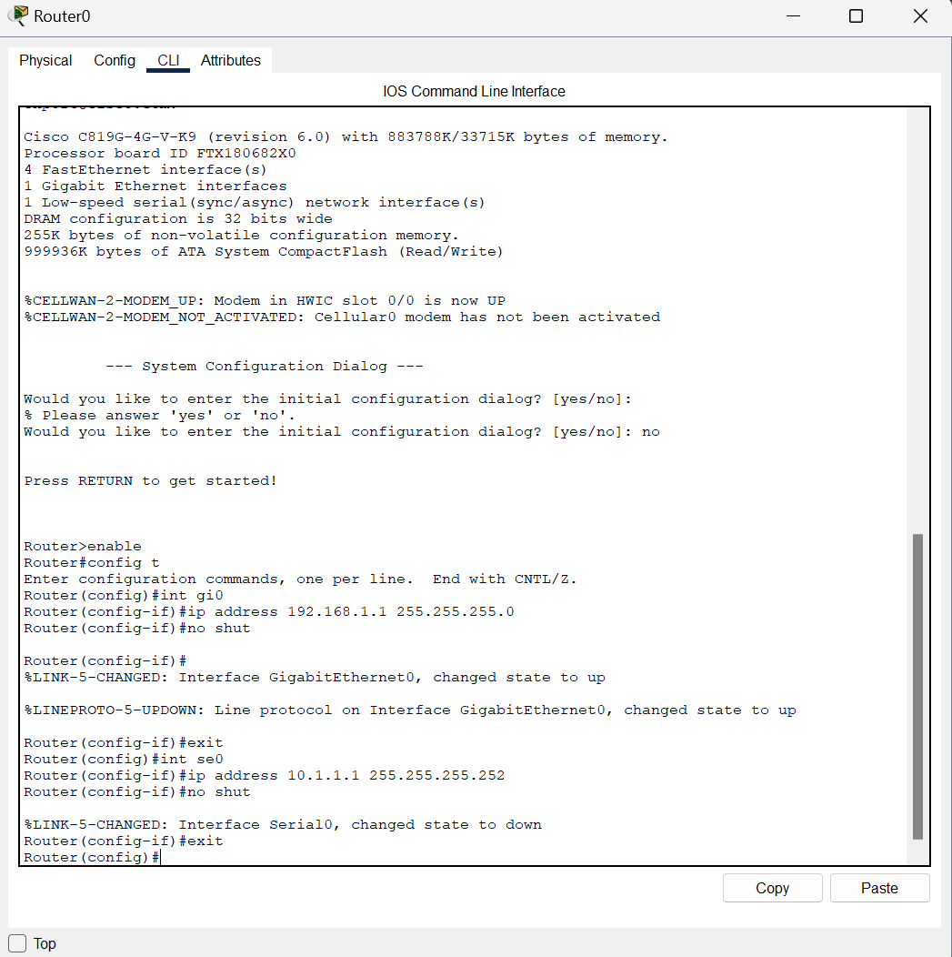

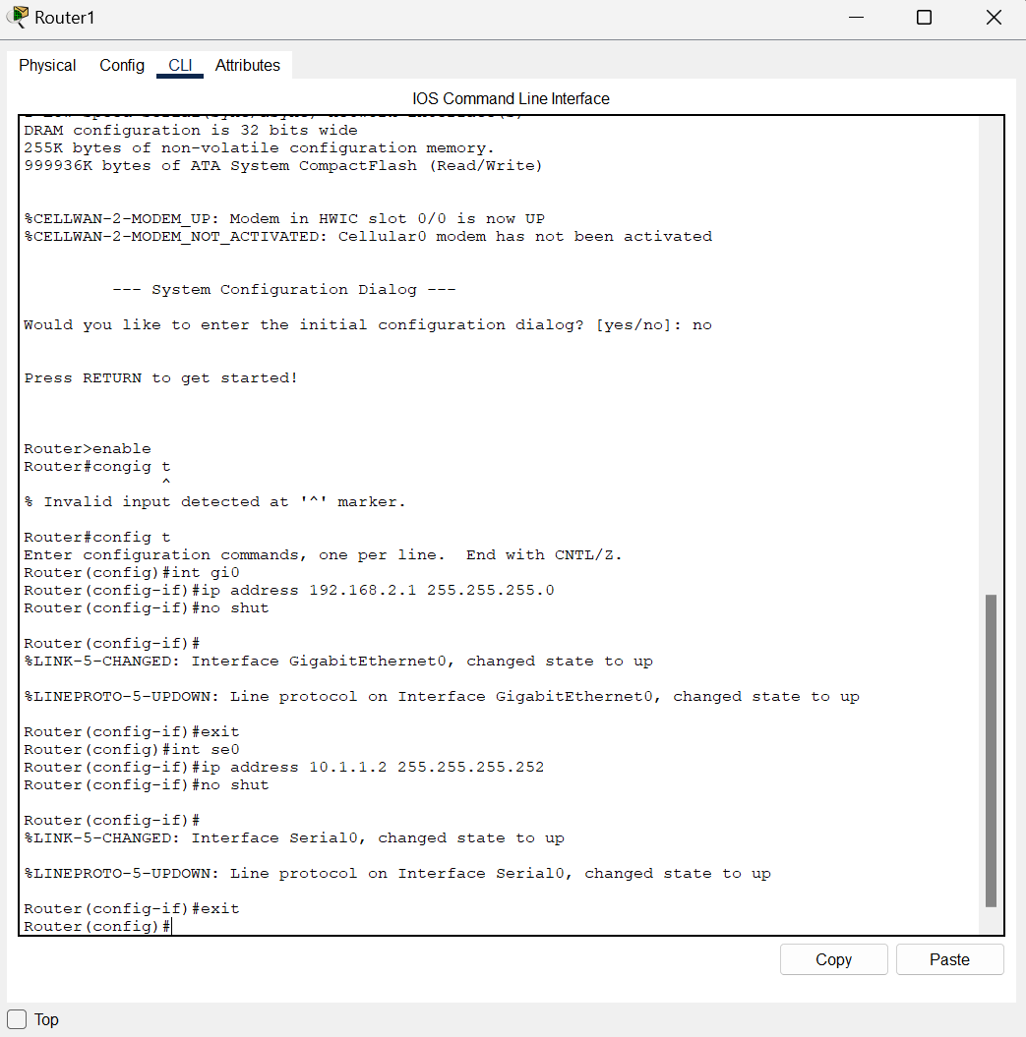

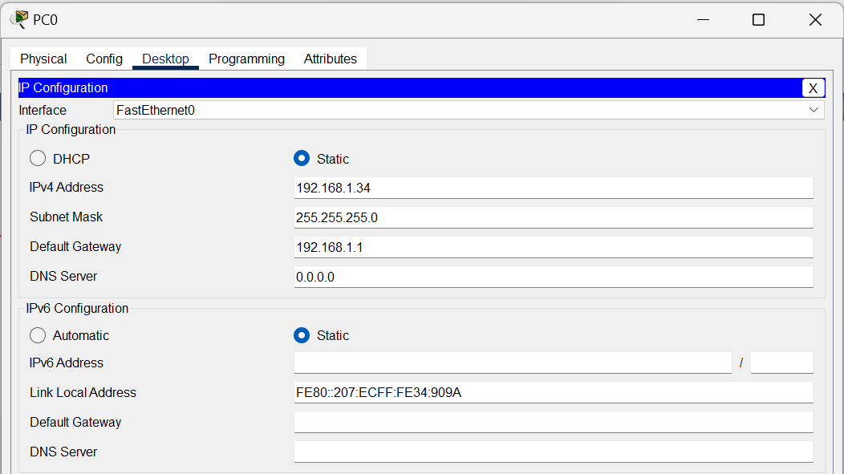

**STEP 3:**

Setting up RIP, OSPF Protocol

Enabling RIP, OSPF Configuration

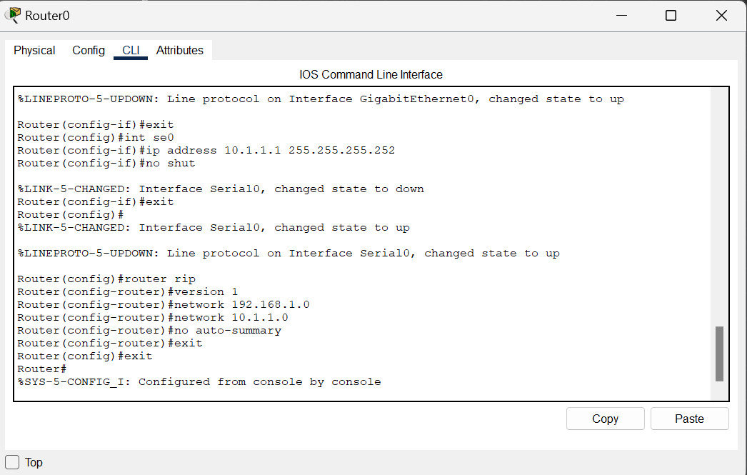

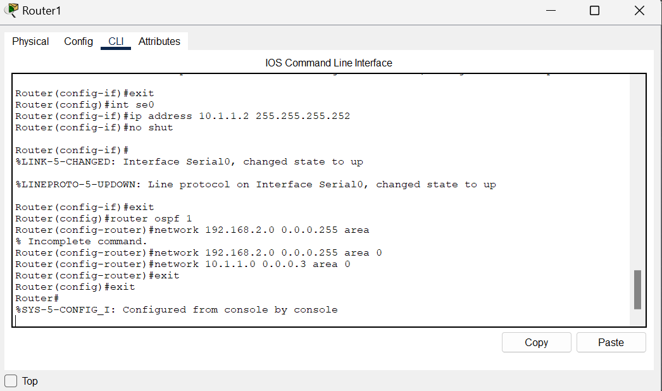

**STEP 4:**

Pinging to check the connectivity

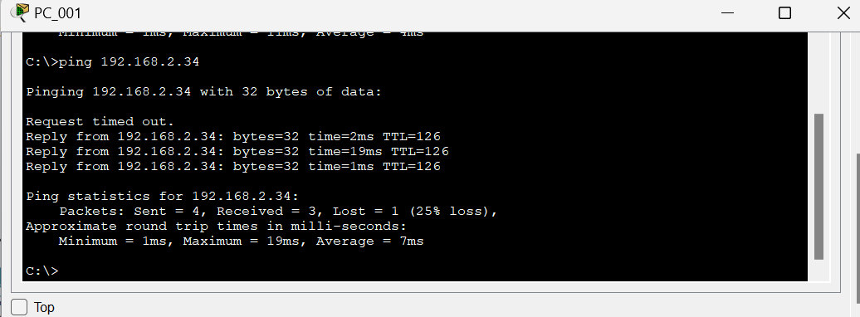

**STEP 5:**

execute the show ip route command to check the tables created on the routers and check the Routes.

